INSTALLATION OPERATING INSTRUCTION

Due to the health contingency situation caused by the Coronavirus SARS-COV-2, also known as COVID-19, the Institute and Kindergarden Thomas Jefferson Campus Guadalajara - Palomar, presents this Instructions for Operation in Facilities that details the application and extension of protocols and Safety, Health and Hygiene measures.
These guidelines allow us to be prepared for the "New Normal", and thus return to our work activity of educational services and, therefore, to face-to-face classes, complying with the regulations and standards indicated by official agencies.
Objective: to safeguard the administrative staff, teachers, students and visitors in general, with the application of the Safety, Health and Hygiene protocols.

Scope: to apply the protocols of action regarding Health and Hygiene. To reinforce hygiene measures inside the facility with the implementation of transferable supplies and consumer goods.

ACCES CONTROL FOR ADMINISTRATIVE PERSONNEL, TEACHERS AND VISITORS
In each of the entrances there will be informative signs (fig. 1) about the procedures to enter the facilities. The process to enter must comply with the following steps:
- Application of antibacterial gel on the hands.
- Taking temperature. The person whose temperature is higher than 37.8 degrees, will not be able to access the facilities.
- Verify the mandatory use of mouth covers. They will be given face masks to all the staff, student or visitor who does not carry one.
- The administrative staff, faculty of security "or 0utsourcing" maintenance, cleaning, suppliers and contractors, must answer a short survey in writing regarding the symptoms of respiratory disease 2 to 3 times per week.
- Attendance registration will be done by scanning the QR code.
- Mats with a disinfectant product for footwear will be placed at all accesses to the facilities.
- To maintain a healthy distance, indicative signs will be placed on the floor of the facilities (sig.2).
- Personnel present in the security booth must wear Personal Protective Equipment (PPE), to take care of the temperature of each of the people who enter the facilities ( fig.).

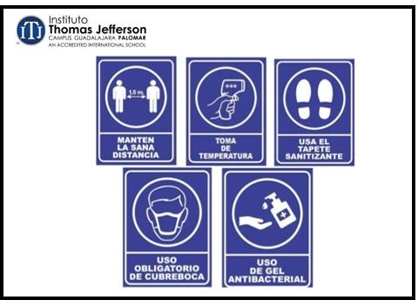
fig.1 fig.2 fig.3

- The access to Gate 4 will be divided into entrance and exit, in order to avoid a probable cross contamination
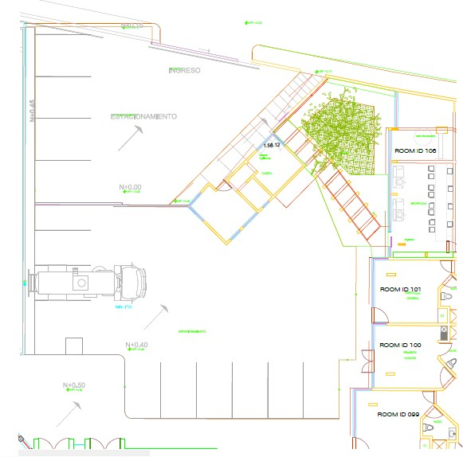
(fig. 4 and 5).
fig.4 fig.5

ACCESS CONTROL FOR STUDENTS
- The temperature will be taken first. This step will be in charge of the teaching staff, who will measure the temperature while the student is inside his vehicle, if the student has a temperature greater than 37.8 ° he will not be able to enter the Institute.
- Teachers support with this activity must to have infrared remote thermometer and with its equipment Personal protective equipment (PPE) (fig.6).
- For the application taking temperature, the teachers must respect and stand on the marks of healthy distance placed on the floor (fig.7 ).
- Only if the student complies with the authorized temperature (less than 37.8 °), will he get out of his vehicle to enter class.
- When entering the facilities, antibacterial gel should be applied in the automatic dispensers.
- Without any exception, you must disinfect your footwear on the sanitizing mats installed at the entrances.
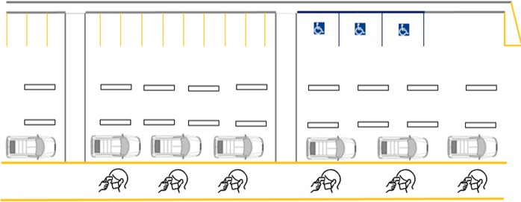
Note: The access of students at stipulated times will be only by Vehicular Circuit, in case of late arrival the entrance will be through Gate 4 and must be accompanied by the parent. (fig.6 fig.7)
.
fig.6 fig.7

FLOWS CIRCULATION FOR STUDENTS, TEACHERS AND SECTION STAFF
In order to prevent and minimize the risk of cross-infection, the Institute will have circulation flows at entry times, exit times for breaks and breakfast times, as well as exit of students, teachers and administrative personnel (fig. 8 and 9 ).
- In given case two or more students have the need to move to the sanitaries, or dispatchers of water, always be conducted by its right, both in the way as in your back ( fig.10 ).
- In case of moving to the cafeteria area, games area, etc. Must move as indicated by the flow sketch s fig.11, 11.1 and 11.2, to return to their classrooms should do so as stipulated in the sketch of the s fig.12, 12.1 and 12.2.
- In Preschool departure time, should be directed how it marks the sketch flow of fig.14 on a staggered schedule. Parents must wait outside Door 3, respecting the healthy distance during the waiting time in which the student is transferred to the exit.
- At the time of departure, must be addressed as it marks the sketch of flow, fig.14 and 15 in one-time step, respecting the safe distance during the waiting time in which the student is picked up by the parent.

FLOWS CIRCULATION IN SCHEDULE OF ENTRY OF STUDENTS AND TEACHERS AND SECTION STAFF
(Lower floor: Preschool and Minor Primary)
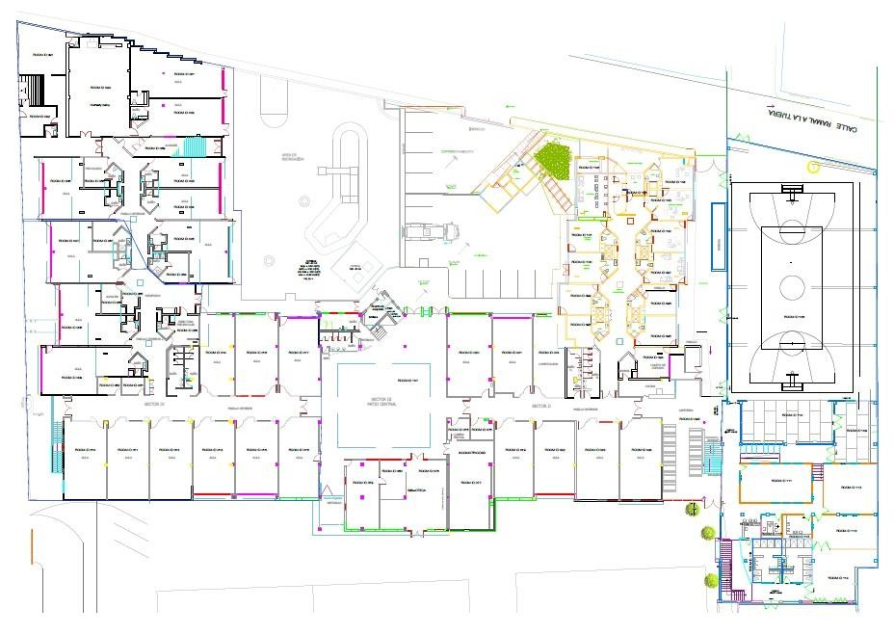

fig.8

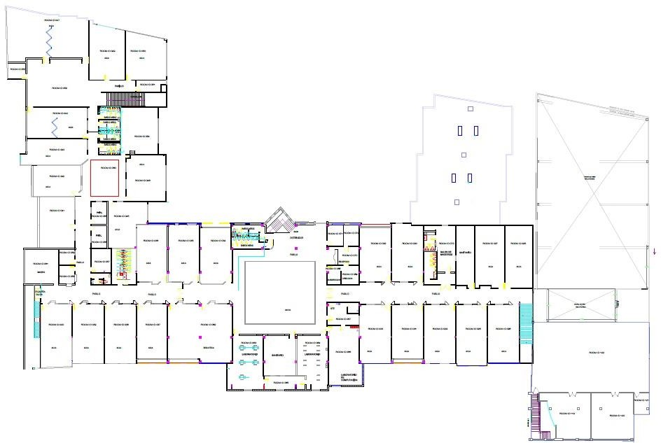
(Upper floor: Secondary and Upper Elemntary)

FLOWS CIRCULATION WHILE ONE OR MORE PEOPLE ARE IN A CORRIDOR
(Upper floor: Middle School and Upper Elementary)
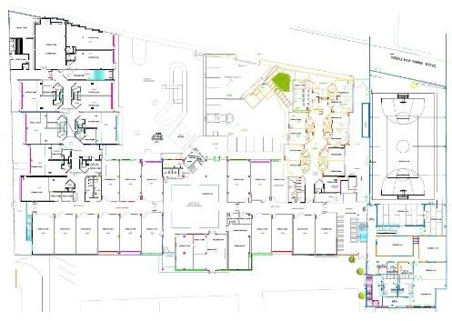
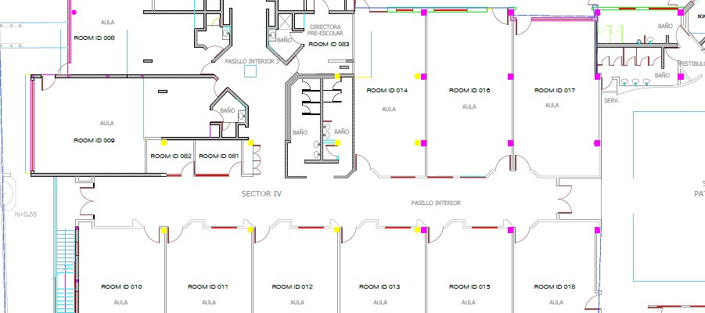
fig.10

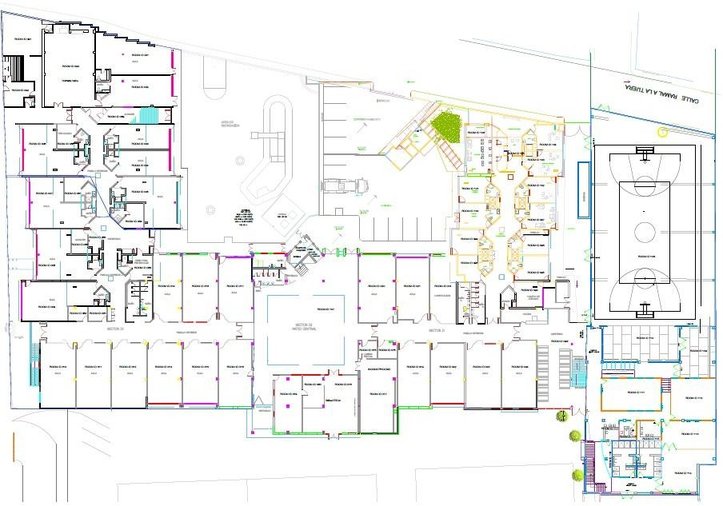
FLOWS CIRCULATION TO EXIT FOR BREAK O CAFETERÍA
LOWER FLOOR

fig.11

FLOWS CIRCULATION TO EXIT FOR BREAK OR TO CAFETERIA

fig.11.2

FLOW CIRCULATION TO RETURN OF RECESS OF CAFETERIA
LOWER FLOOR

fig.12

FLOWS CIRCULATION TO RETURN OF RECESS OR CAFETERIA
LOWER FLOOR

fig.12.1

FLOW CIRCULATION FOR DISMISSAL HOURS OF PRESCHOOL

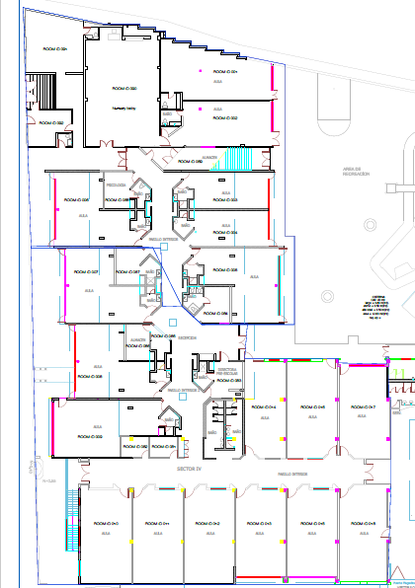
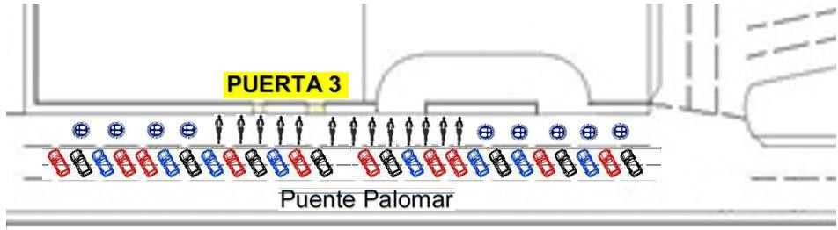
fig.13

FLOWS CIRCULATION FOR DISMISSAL SCHEDULE OF STUDENTS, TEACHERS AND SECTION I ON STAFF

fig.14

FLOWS CIRCULATION FOR DISMISSAL SCHEDULE OF STUDENTS, TEACHERS AND SECTION I ON STAFF
(Upper floor: Middle School and Upper Elementary)

CIRCULATION FLOWS FOR ACCESS TO ADMINISTRATIVE STAFF AND VISITORS FACILITIES

The Institute will have circulation flows during entry hours, for administrative personnel that concentrates the areas of Administration, Cash, Reception, School Control and visitors, these were designed in order to prevent and minimize the risk of cross-infection (fig. 16).
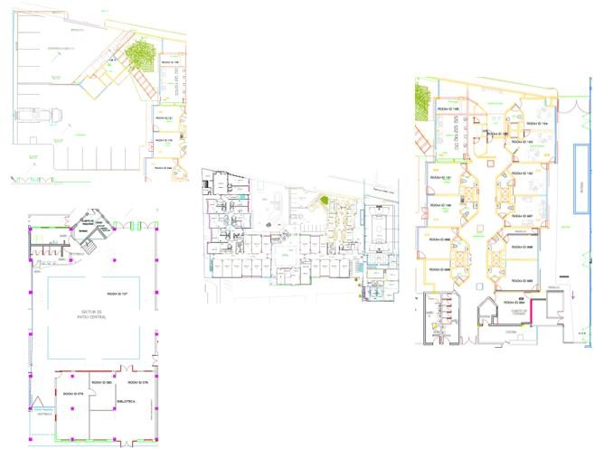

fig.16

FLOWS CIRCULATION FOR LEAVING STAFF ADMINISTRATIVE AND VISITORS

The Institute will have circulation flows during entry hours, for administrative personnel who concentrate the areas of Administration, Cash, Reception, School Control and visitors, these were designed in order to prevent and minimize the risk of cross-infection (fig. 17) ).

fig.17

CLEANING AND DISINFECTION PROTOCOL OF FACILITIES
(Before, during and after)

BEFORE / OPENING OF FACILITIES:
Before the start of operations and income administrative staff and students, academics, the cleaning staff of "First Care" held the misting in halls of sections, offices, bathrooms and areas common facilities.

DURING:

During the workday and student in the corridors of each section and school will feature housekeeping staff called "Guards sanitization", who will be responsible to clean and sanitize any object or surface that people have contact, example:
- Classrooms and / or laboratories door handles.
- Aisle switches or switches.
- Hallways door handles.
- Water dispensers
It will also be the "Guard of Baths" who will be the responsibility of managing the capacity of students in health, as well as reinforce the frequent cleaning toilets, sinks, urinals, paper - handle, in order to minimize contact transmission direct or indirect objects.

In times of recess of the students scheduled for the section. the "Guard of Sanitizing" from entering into the room for a sanitization surfaces and objects that are within the same.

AFTER

Once the school day is over, the cleaning teams will enter each classroom, section office, and administrative offices, to carry out the ordinary cleaning work, which comprises two steps:
1.- Cleaning. Before using disinfectants, cleaning surfaces should be done with soap and water to reduce dirt and eliminate germs.
2.-Sanitation. Cleaning of areas should be completed with sanitization of surfaces and objects. Surfaces as disinfected with product Sanitizer "Exmicror and Alphas PH”, a multipurpose disinfectant based on technology of Hydroxide of Peroxide it speeded up. Due to its special formulation, this product also cleans and disinfects surfaces without damaging them, it is recommended to be used on most hard and non-porous washable surfaces. This product should be used to disinfect frequently touched surfaces, the amount of time this disinfectant must remain on surfaces to be effective is ten minutes after application.

The objects and surfaces for cleaning and sanitizing are the following:

- Tables and desks
- Door handles
- Light switches
- Phones
- Keyboards
- Toilets
- Faucets and sinks
- Touchscreens
- Computer equipment

Digital and physical technical sheets of sanitizing products are attached:
https://www.biorganicosrobech.com.mx/exmicror/
https://www.johnsonprofesional.com/fichas_tecnicas/Johnson_Profesional_Diversey_Ficha_Tecnica_Alpha_HP.pdf

In the case of articles that children might put in their mouths, such as toys and other children 's items should be cleaned s or so with soap and water and sanitize with ethyl alcohol.
The cleaning staff must have uniform and with their Personal Protective Equipment (PPE) consisting of gloves, mouths and protective lens covers (fig.18 )
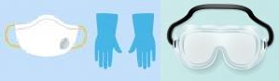
Fig.18

Note: Cleaning staff should wash their hands frequently with soap and water for 40 seconds, even immediately after removing gloves. If soap and water are not available and your hands are not visibly dirty, you can use antibacterial gel. However, if your hands are visibly dirty, you should always wash them with soap and water.

CAPACITY AND DISTRIBUTION OF STUDENTS AND DESKS BY SECTION.
By regulations applicable to social distancing, tables and desks will n with a perimeter of 1.5 meters to the round, as well as one capacity minimum of 10 and maximum of 14 students, counting one distribution strategy inside of the classroom to give compliance to this regulation, such as is shown in fig. 19 and 20.
Preschool section.

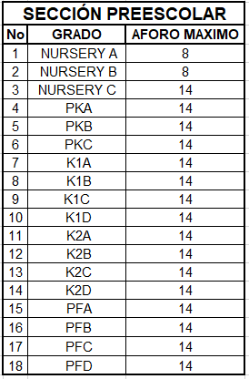
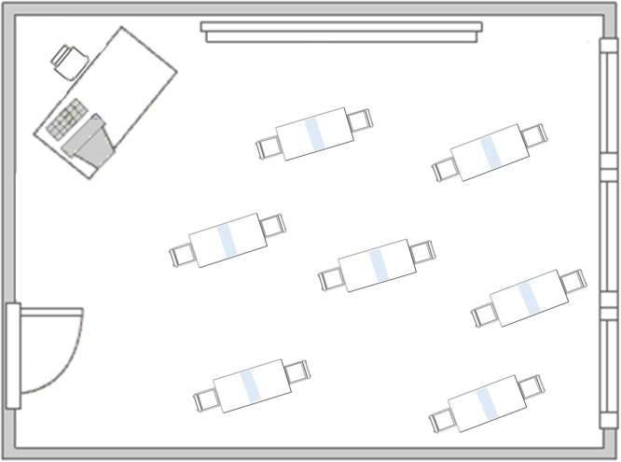
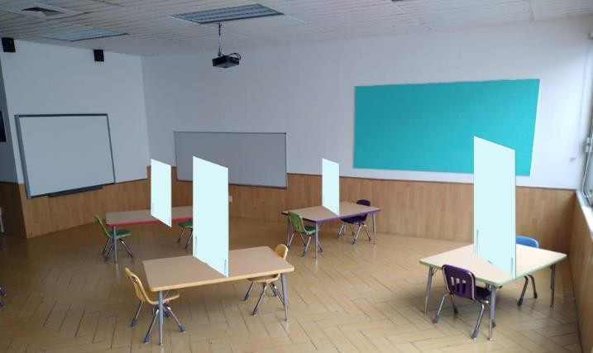

Elementary, Middle School and High School Section
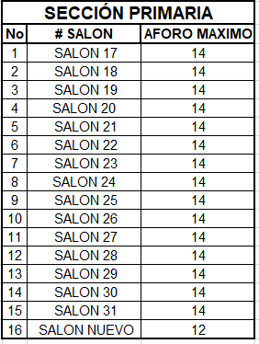
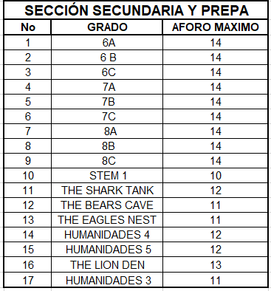
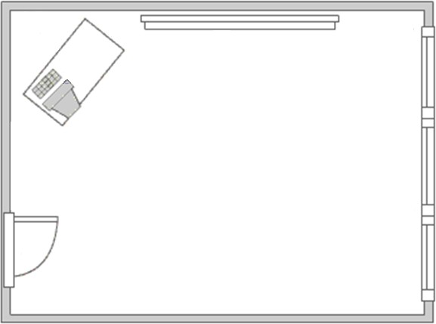
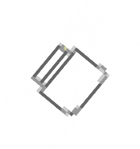

fig.19

OUTSOURCING ACCESSES: CAFETERÍ A AND UNIFORMS
Access to the Campus by Cafeteria and Uniform “Outsourcing” staff must enter through Door 4 to register their access, as well as comply with the established hygiene protocols:
- Use of mouth covers upon entry and during your stay at the facilities
- Temperature measurement (no greater than 37.8 °).
- Application of antibacterial gel
- Sanitation of Footwear
- Answer Covid-19 Radar questionnaire, when required by security personnel.

When entering or leaving the facilities, they should do so through the circulation flow route for “Outsourcing” fig.20.

fig.20

Note: Campus exits for the purchase of food, drinks, etc. are totally restricted.

SUPPLIER INCOME FOR OUTSOURCING.

Note: The Outsourcing must plan, as far as possible, the deliveries of materials by its suppliers, as well as respect the reception schedules of materials granted by ITJ Palomar. The following information must be notified to the security booth:

Name of the Company or supplier
Product to be delivered
Delivery date and time

The supplier must comply with the protocols of hygiene to gain access to the facilities of the Institute, as well as Outsourcing should adhere and comply with the protocols of sanitization of merchandise described in below.

Supplier entry protocol for Outsourcing

- Access control entry record.
- Use of mouth covers upon entry.
- Temperature taken (not higher than 37.8 °).
- Antibacterial gel application.
- Footwear Sanitation.
- Answer Covid-19 Radar questionnaire.
- Use of gloves to deliver merchandise.
- Enter through the access door indicated by the security guard (suppliers or Gate Cero).

Protocol for the reception and sanitation of material and supplies for Outsourcing

1.- The supplier must enter through the indicated door (suppliers or Zero Door) and go to the indicated corridor.
2.- The reception of the material must be made by the Outsourcing manager (Cafeteria or Uniforms) in the supplier hall or entrance to uniforms.
3.- The outsourcing provider has restricted access to campus facilities.
4.- The supplier must carry his mouth guard and unload the material or supplies with gloves.
5. In the download and receive the goods the responsible Outsourcing (Cafeteria or uniforms) should receive the goods with gloves, sanitize each product (box, plastic bags, packages, etc.) with sanitizing product, which must remain in contact with product for ten minutes to be effective after application (fig. 21).
6.- At the end of the sanitation, the materials or supplies may enter the Campus. 7.- The supplier must go to gate booth 4 to register his departure.

fig.21

ITJ SUPPLIER ACCESS

The staff of ITJ should the plan on the extent of the possible the delivery of materials for part of their suppliers and respect schedules reception of the materials used must give notice to guardhouse the following information:

Name of the Company or supplier
Product to be delivered
Delivery date and time

The Supplier must comply with the hygiene protocols for access to the Institute's facilities

- Entry Record in Access Control
- Use of mouth covers upon admission
- Temperature taking No higher than 37.8 °
- Antibacterial gel application
- Footwear Sanitation
- Answer Covid-19 Radar questionnary
- Use of gloves to deliver merchandise
- Enter through the access door that the Security Guard indicates (Suppliers and / or Zero Gate)

Reception and Sanitation Protocol for material and supplies.

1.- The Supplier must enter through the indicated door (Suppliers and / or Zero Door) and go to the indicated corridor
2.- The reception of the material must be carried out by the person in charge who placed the order, the delivery of the material will be through the supplier corridor and / or entry to uniforms.
3.- The provider has restricted access to campus facilities
4.- The supplier must carry his mouth cover and unload the material and / or input with gloves
5. To download and receive the goods Responsible receiving the material, should receive the goods with gloves, sanitize each product: Box, Bag of Plastic, packages, etc; with product sanitizing the which must remain in contact with the product for ten minutes for me to be effective after application, fig.22
6.- At the end of the sanitation, the materials and / or supplies may enter the Campus. 7.- The supplier must go to gate booth 4 to register his departure.

fig.21

CAPACITY AND DISTRIBUTION OF STUDENTS IN CAFETERÍ A.
To comply with the social distancing regulations, 9 tables will be placed which will have a separation of 1.20 m. An acrylic will also be installed that will separate and provide protection to the diners. The capacity inside will be 36 people with OPTION A and 18 people with OPTION B, as shown in fig. 22.
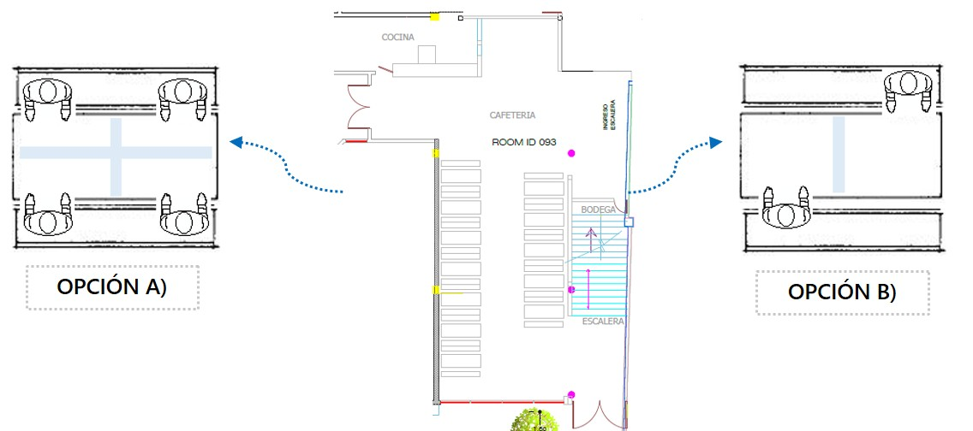
fig. 22

STORAGE, COLLECTION AND TRANSPORT OF HAZARDOUS BIOLOGICAL - INFECTIOUS WASTE (RPBI)
Because the c ontingencia by the COVID-19 and for purposes of Regulation NOM-087-ECOL-SSA 1-2002, waste as covering masks, gloves or disposable surgical apparel are considered WASTES BIOLOGICAL - INFECTIOUS (RPBI) , as these may cause adverse effects to health and the environment, so that actions will be taken for handling as the due storage and disposal thereof by a specialized supplier.

Storage
Plastic containers will be installed with a red lid and the legend " DANGEROUS BIOLOGICAL-INFECTIOUS WASTE" . They are located strategically within the facilities of the Institute without obstructing access roads and circulation, in order to place in these wastes as covering masks, gloves or surgical disposable clothing. This storage will be temporary , since there will be a collection schedule for them.
Harvest
It is hired a specialized company in collecting, handling, transportation and disposal of hazardous waste, Biological - infectious, receiving as evidence the "Manifesto of Delivery, Transport and Waste Reception Dangerous. Said company will carry out the collection according to the schedule, according to the amount of RPBI generated on site. This operation must be supervised by the Cleaning Department, and the personnel of the collection company that enters the Campus, must follow the supplier entry protocols.

